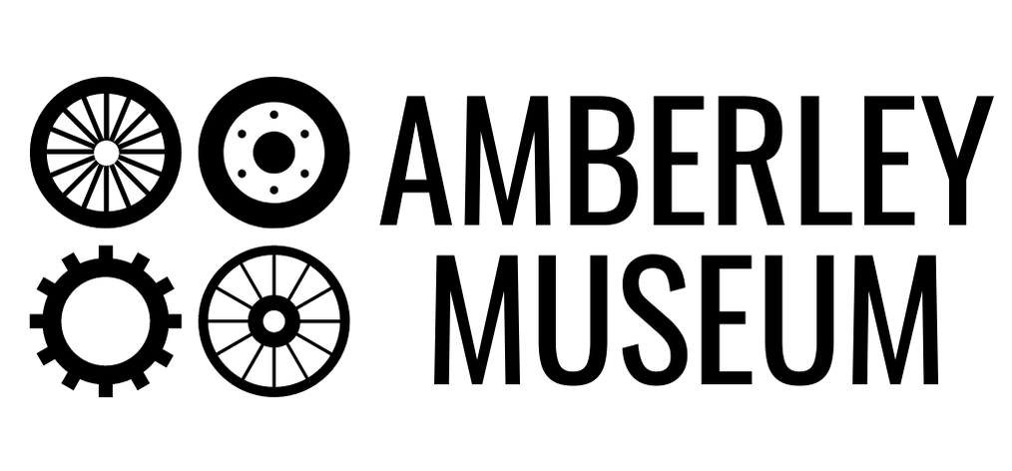
Loan box booking form
Please complete section 1 of this form then return via email to learning@amberleymuseum.co.uk.
Your booking will be confirmed when we return this form with section 2 completed.
Section 1 – Booking Enquiry
Contact name
Email
Invoicing email (if different)
Telephone
Organisation name
Organisation address
Date of enquiry |  |  |  |  |  |  | 1st choice start date
N.B. Boxes are quarantined between loans for at least 72 hours. |  |  |  |  |  |  | 2nd choice start date
Year/age group (schools) |  |  |  |  | Number of people that will use the resource (for evaluation purposes)
Which loan box would you like? (Please tick)
Schools |  |  |  |  |  | Elderly groups
Communications |  |  |  |  |  | Beauty & Boudoir
Everyday Inventions |  |  |  |  |  | Kitchen & Medicine Cabinet
Transport |  |  |  |  |  | Office & Commemorative
Duration of loan (Please tick)
2 weeks: £40
4 weeks: £80
By committing to this loan, I agree to use the Museum’s objects in accordance with the guidance document supplied to me by email. I understand that I may be charged for any loss or damage to these objects, at the Museum’s discretion.
Signed |  |  |  |  |  |  | Date
Amberley Museum will process the data provided on this form for the legitimate interest of educational bookings at the Museum, providing you with the necessary information to make the most of your visit, in compliance with GDPR regulations. This is covered by our privacy statement which is available on www.amberleymuseum.co.uk and from the Museum office.

Section 3 – Out-in record
Date of pick-up |  | Signed
Date of return |  | Signed
Section 2 – Confirmation
Your loan is confirmed for the period *** - ***.
You will shortly receive an invoice for £**.**, which must be paid before collecting your box from the Museum.
Please contact learning@amberleymuseum.co.uk to arrange collection and for any questions or queries.
Signed |  | Date

